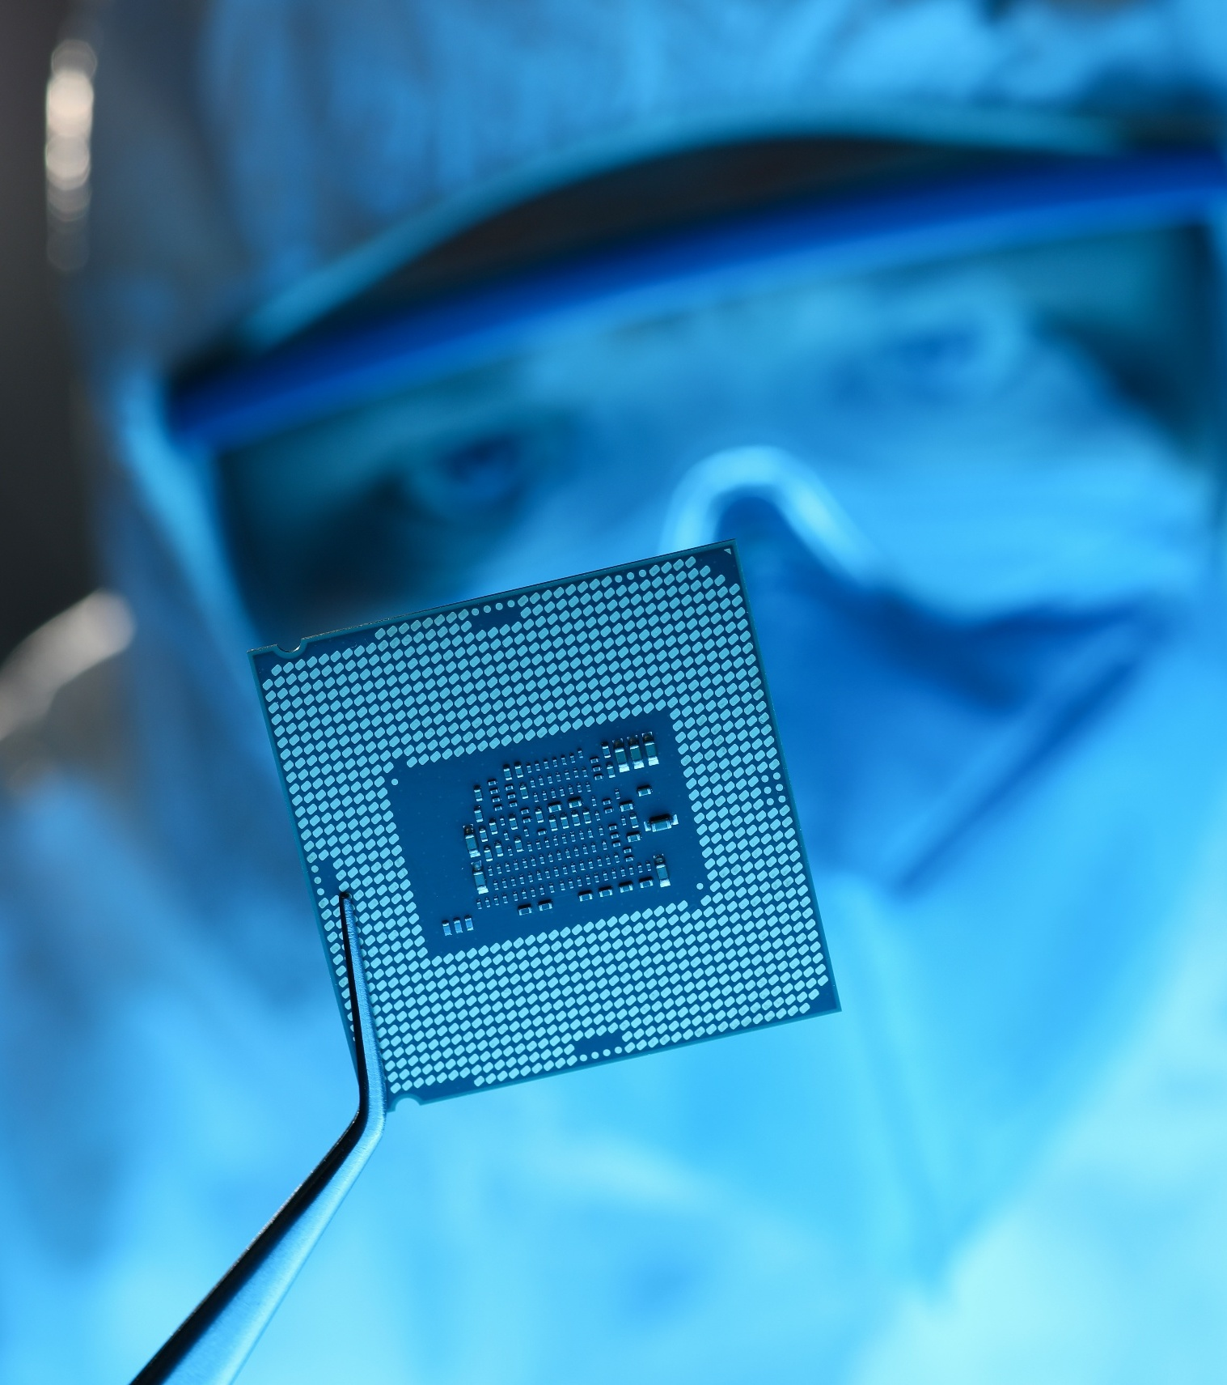






HMGCC Co-Creation
Clarification Questions: Antenna-Boosting Materials

Document Details: Clarification Q&A in response to the call for proposals
Challenge: Antenna Boosting Materials
Deadline for questions: 09/01/2026
# | Question | Answer
1. | In the Context of the challenge section on the HMGCC Co-Creation Security Challenge Form for Antenna-boosting Materials, it states (page 2): "Recent publications have suggested that using novel, solid and uniform materials with frequency dependent dielectric constants could widen the bandwidth of antennas, giving many advantages."  Please can you provide the references for these publications, as this is key to understanding the challenge scope. | X. Yang, E. L. Bennett, I. Calisir, Q. Hua, J. Xiao and Y. Huang, "A Study of Wideband Dielectric Resonator Antennas Loaded With Special Dispersive Materials," in IEEE Open Journal of Antennas and Propagation, vol. 5, no. 6, pp. 1658-1670, Dec. 2024, doi: 10.1109/OJAP.2024.3436557.  Ilkan Calisir, Xiantao Yang, Elliot L. Bennett, Jianliang Xiao, Yi Huang, "Enhancing the bandwidth of antennas using polymer composites with high dielectric relaxation," Materials Today Electronics, Vol 3, 2023, https://doi.org/10.1016/j.mtelec.2023.100026.

